Preparing Perfect Muffins

Overview
The muffin method is the mixing method to use when your recipe doesn’t contain much fat (and it is all in liquid form) to make sure your muffins, quick breads, and pancakes bake up nice and tender.

Top Sellers
Homemade muffins are so much better than anything at your corner cafe. From classics like blueberry to more elaborate ones like French toast, there are tons to choose from. The muffins that made this list span a wide variety of flavors and textures, so breakfast never needs to be boring again!

- Banana crumb muffins
- Lemon poppy seed muffin
- Chocolate chocolate-chip muffins
- Apple cinnamon muffins
- Pumpkin muffins
- Streusel topped blueberry muffins

Processes

Weighing
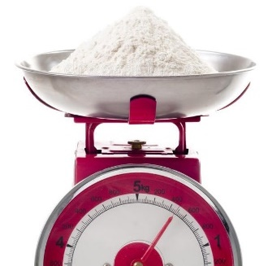
Know the weight of your mixing bowl before you start. Once you've mixed up your batter, put the bowl on the scale and weigh it. Subtract the weight of the bowl, to establish the weight of the batter.
Do some simple arithmetic: divide the weight of the batter by the number of portions the recipe calls for (e.g., 12 muffins; 24 cupcakes; 2 round cake layers).
Scoop out that amount of batter for each muffin (or cake layer, etc.)

Mixing
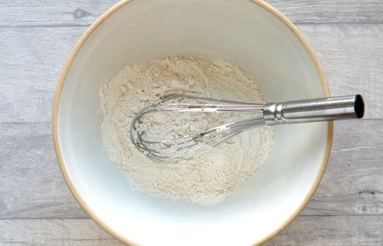
It is very possible to overmix muffin batter. In fact, I’d guess that it happens more often than not in most cases. Most muffins are mixed using the muffin method, which incorporates all the wet ingredients into the dry ingredients all at once. This method is used to create the desired texture of muffins, but it also helps you get your batter made with minimal mixing to avoid toughness.

Portioning
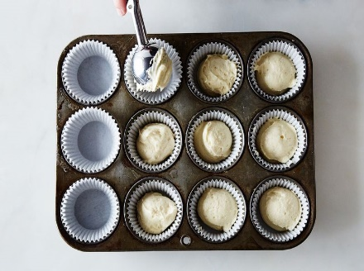
My preferred method for portioning muffin batter is with a scoop. Many standard size muffins need about 3 tablespoons of batter per cup, so a 3-tablespoon scoop is the perfect tool for portioning and transferring the batter. All your muffins will be the same size, which is not only nicer looking but also important for making sure the muffins all bake evenly. It’s also a quicker and less messy method. Once you try it, I think you’ll be sold on doing it that way!

Baking

Bake in preheated oven for 20 to 25 minutes, until a toothpick inserted into center of a muffin comes out clean. Bake muffins at 400° F for 15 to 17 minutes, or until a toothpick inserted in the center comes out with little to no crumbs. Let muffins cool in the pan for 5 minutes before transferring to a cooling rack. Serve warm

Cooling
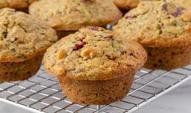
As a general rule, allow muffins -- even those with fresh fruit -- to cool inside the pan for a minimum of five minutes but no more than a half hour. Transfer the muffins from the pan to a baking rack and allow them to cool for an additional 10 to 15 minutes.
If you cool the muffins in the tray for too long, the bottoms of the muffins will become soggy

Depanning

The muffin tray will still be hot! Protect your hands with hot pads or a dry towel when you remove the muffins from the muffin tray.
Run a small knife or spatula around the sides of the muffin cups to loosen them from the muffin tray. Invert the muffin tray and pop the muffins out. Tap gently on the bottom of each muffin cup if necessary.

Serving
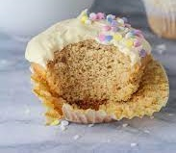 Offer to the reheat muffins for customers. Heat for 7 seconds in the microwave and serve on a plate.
Otherwise, place the muffin in a white bakery bag.

